**\*PRESENT CONTINUOUS\***

*It is Saturday. Rosa isn’t working today.

A) What is she doing?

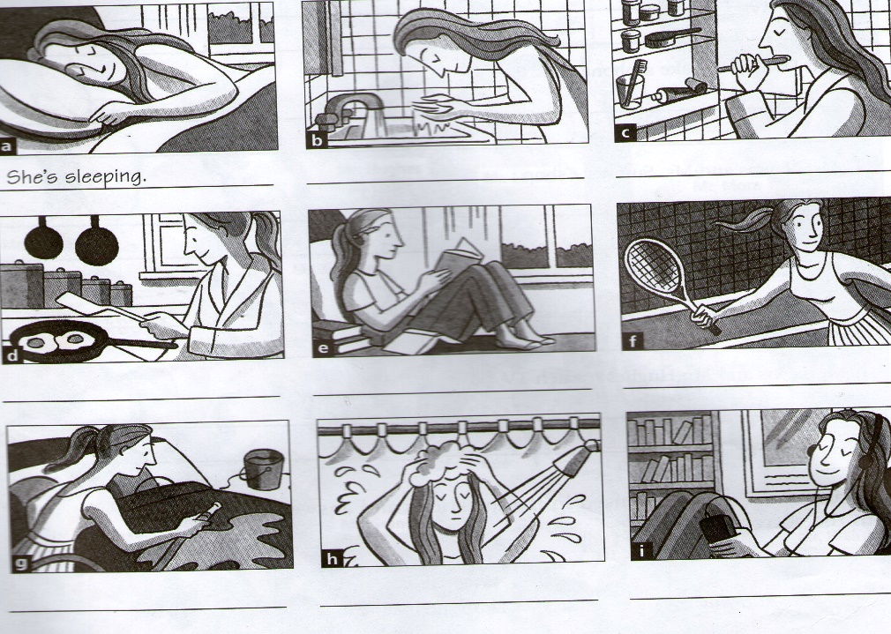

a. _______________________.

b. __________________________.

c. __________________________.

d. __________________________.

e. __________________________.

f. __________________________.

g. __________________________.

h. __________________________.

**B)** Answer the information questions:

1. What is she having for breakfast?

2. Where is she reading a book / studying?

3. Who is she playing tennis with?

4. What time is she washing her car?

5. When is she listening to music?

**D)** What about you? Answer the questions with your personal information.

1. It’s Sunday. It’s 5 p.m. What are you doing?

2. It’s Wednesday. It’s 12 noon. What are you doing?

3. It’s Monday. It’s 3 p.m. What are you doing?

4. It’s Saturday. It’s 10 p.m. What are you doing?

5. It’s Friday. It’s 7 p.m. What are you doing?